1. DIFFERENCE BETWEEN HTTP1.1 VS HTTP2

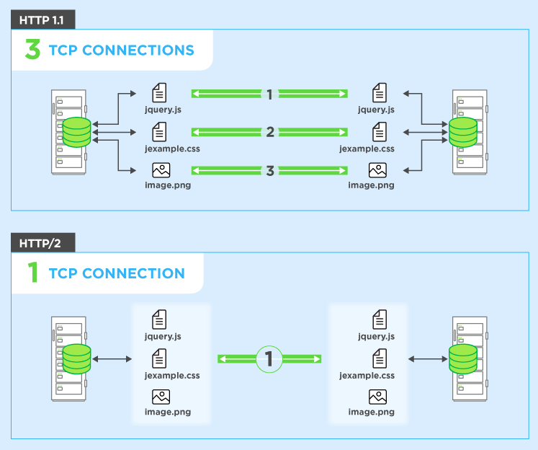

[HTTP](https://www.cloudflare.com/learning/ddos/glossary/hypertext-transfer-protocol-http/) stands for hypertext transfer protocol, and it is the basis for almost all web applications. More specifically, HTTP is the method computers and servers use to request and send information. For instance, when someone navigates to cloudflare.com on their laptop, their web browser sends an HTTP request to the Cloudflare servers for the content that appears on the page. Then, Cloudflare servers send HTTP responses with the text, images, and formatting that the browser displays to the user.

The first usable version of HTTP was created in 1997. Because it went through several stages of development, this first version of HTTP was called HTTP/1.1. This version is still in use on the web. In 2015, a new version of HTTP called [HTTP/2](https://www.cloudflare.com/website-optimization/http2/what-is-http2/) was created.

HTTP/2 solves several problems that the creators of HTTP/1.1 did not anticipate. In particular, HTTP/2 is much faster and more efficient than HTTP/1.1. One of the ways in which HTTP/2 is faster is in how it prioritizes content during the loading process.

1. HISTORY OF HTTP

The term [hypertext](https://en.wikipedia.org/wiki/Hypertext) was coined by [Ted Nelson](https://en.wikipedia.org/wiki/Ted_Nelson) in 1965 in the [Xanadu Project](https://en.wikipedia.org/wiki/Xanadu_Project), which was in turn inspired by [Vannevar Bush](https://en.wikipedia.org/wiki/Vannevar_Bush" \o "Vannevar Bush)'s 1930s vision of the microfilm-based information retrieval and management "[memex](https://en.wikipedia.org/wiki/Memex" \o "Memex)" system described in his 1945 essay "[As We May Think](https://en.wikipedia.org/wiki/As_We_May_Think)". [Tim Berners-Lee](https://en.wikipedia.org/wiki/Tim_Berners-Lee) and his team at [CERN](https://en.wikipedia.org/wiki/CERN) are credited with inventing the original HTTP, along with HTML and the associated technology for a web server and a text-based web browser. Berners-Lee first proposed the "WorldWideWeb" project in 1989—now known as the [World Wide Web](https://en.wikipedia.org/wiki/World_Wide_Web). The first version of the protocol had only one method, namely GET, which would request a page from a server. The response from the server was always an HTML page.

1. DFFERENCES BETWEEN NODE JS AND BROWSER JS

|  | **Javascript** | **NodeJS** |
| --- | --- | --- |
| 1. | Javascript is a programming language that is used for writing scripts on the website. | NodeJS is a Javascript runtime environment. |
| 2. | Javascript can only be run in the browsers. | NodeJS code can be run outside the browser. |
| 3. | It is basically used on the client-side. | It is mostly used on the server-side. |
| 4. | Javascript is capable enough to add HTML and play with the DOM. | Nodejs does not have capability to add HTML tags. |
| 5. | Javascript can run in any browser engine as like JS core in safari and Spidermonkey in Firefox. | Nodejs can only run in V8 engine of google chrome. |
| 6. | Javascript is used in frontend development. | Nodejs is used in server-side development. |
| 7. | It is the upgraded version of ECMA script that uses Chrome’s V8 engine written in C++. | Nodejs is written in C, C++ and Javascript. |

1. WHAT HAPPENS WHEN WE TYPE URL IN THE ADDRESS BAR
   * The browser looks up the IP address for the domain name via DNS
   * The browser sends a HTTP *request* to the server
   * The server sends back a HTTP *response*
   * The browser begins rendering the HTML
   * The browser sends requests for additional objects embedded in HTML (images, css, JavaScript) and repeats steps 3-5.
   * Once the page is loaded, the browser sends further async requests as needed.